**Senior Project Report**

1. **Introduction**

This report is divided into three sections. Section I outlines the format of both this report and the project, Section II contains a script of my speech, and Section III explains the code that I built for this project.

The overarching theme for this project is plunging; I consider every activity or experience mentioned in this presentation a plunge. The activity is about coding.

The presentation is split up into three sections, called “hiding”, “growth”, and “fulfillment”. Each of the sections elaborates on these words and their importance to plunging in my life. Between each segment of the presentation, I offer the class a challenge. Each challenge is an online puzzle that I have created in which the answer to the puzzle is the word of the next section. In order to keep the project on schedule, I set a time limit for each puzzle and then continue to the next segment of my presentation. After I have completed all three segments of the presentation, I ask everyone to navigate to the starting point of my puzzle game. I explain how the game works and go through the first introductory level with the class so that people are not confused, and then leave the rest of the time remaining to let others play the other four levels of the game.

In total, there are eight unique puzzles that I have coded, three miscellaneous challenges and the five levels of the game I made. In the third section I will explain the details of the puzzles and motivation for including them.

1. **Script**

Note: the format in this is informal English!

Hey all, before I plunge into this, I’d just like to let you know what the format of the presentation is so you guys aren’t confused.  There are going to be 3 challenges in the middle where I will give you all a certain time to solve some sort of online puzzle that I have created. None of them involve any actual coding but I tried to make them showcase some cool stuff that you can do with coding. After my presentation, there’s going to be a longer activity in which you’ll get a chance to play this puzzle game that I’ve made.

Every good project has some metaphor or theme; mine is plunging. Unlike other people who have dedicated many years to a few extracurriculars and become experts in whatever they do, I’ve just kind of plunged into a bunch of little things out of my comfort zone. The culmination of these activities and experiences make me who I am today.

Before we can get there, here is my first challenge for you guys: navigate to this link (show link in presentation). Play around with it, you have 3 minutes to solve this.

*HIDING*

So, you just completed this puzzle in which the passcode was hiding.

Though I didn’t know it at the time, the majority of my freshman year was characterized by what I now consider to be hiding. However, it wasn’t hiding in an overt sense, it was more like sleeping on the possibilities of how to think or spend my time. I felt no obligation to go out and involve myself in Homestead clubs, sports, or events, or talk to people I had not talked to in middle school, or try to pursue any passions; I didn’t really even know what my passions were. At that point, I didn’t really have my own unique personality.

My first plunge in the spring of freshman year was learning programming. if you didn’t tell already this presentation has a bit of a technology and coding theme to it. This is because coding is one of my big passions.

For the first several months, I was far from an expert. I wasn’t actually taking the java course, so I didn’t really understand anything at first. But learning coding gave me a sense of satisfaction because for the first time, I was spending my free time doing something that I thought would actually provide some long-term value. I spent a lot of my freshman and sophomore years coding, but in the past two years I haven’t really done any coding during the school year, because I’ve been busy. It’s still one of the meaningful activities to me and something I plan to pursue in the future. (pause).

Before we continue to some other plunges here’s another challenge, navigate to this link and do it, you have 3 minutes to solve this.

*GROWTH*

Alright, so if you were able to solve that in the time allotted, the keyword there was growth. I’ve realized that every plunge allows one to grow and change as an individual.

My sophomore year, I joined the cross-country team, which was definitely a plunge as I hadn’t run competitively since the time that I am not allowed to discuss during this presentation, I wasn’t used to the mileage, and my knees were kind of messed up for about half of the season. However, looking back, I’m glad I ran; I’ve made some essential friendships from the cross country and track teams, and I learned that I really enjoy running. After sophomore year, I didn’t continue cross country, though I now run distance events in track.

In terms of growth, from running, I’ve become a more disciplined person. On a typical day, I never feel like running but after mustering up the strength to go out and run, I feel mentally free and energized. I feel like running is kind of like my form of meditation, so even though it’s physically tiring.

I’ve also grown from tutoring at this organization called Breakthrough, which I joined last year. Breakthrough works with kids from low income areas of San Jose and guides them to set them up to go to college. They push them to apply to private high schools because they qualify for full-tuition need-based scholarships and take difficult classes.

I signed up to be a tutor for Calculus, which was a plunge for me because (1) I had never formally tutored before, (2) I was still taking Calculus at the time. Last year, I was paired up with this senior named Leo. This year, I tutor a sophomore named Josue in Pre-calculus every Wednesday.

I actually wrote my common app essay about Breakthrough, and the most important thing I learned was the role of confidence and friendship in learning. Starting out, tutoring sessions were pretty difficult because Leo refused to communicate. But in a few months, after we legitimately became friends, he would tell me all his insecurities about Calculus and how utterly lost he felt because he lacked fundamentals of math knowledge. From this experience, I think I became more emotionally intelligent and empathetic and less judgmental.

Alright, before we start the final part of this presentation, here is the third challenge. This one is pretty difficult so I’m going to give you guys 6 minutes.

*FULFILLMENT*

That puzzle was long and much tougher than the others, but it must have been pretty satisfying and fulfilling if you were able to solve it. Coincidentally, the password was “fulf1llment”. There’s a 1 in the middle so even if you decided to cheat and use an online anagram solver the answer wouldn’t show up.

For me, plunging, trying new things or going out of my comfort zone, is usually fulfilling. A few plunges which exemplify this have been joining Indopak and going to a research program last summer.

This year I tried out for a few Indopak teams, even though I had never done any sort of dance before. I just decided to join because it would probably be interesting, and it has indeed been fun. So, even though it was slightly uncomfortable when I first started and I still don’t know what I’m doing half the time, dancing is enjoyable and fulfilling.

Last summer I went to a program called the Simons Summer Research Program, in which high school kids help out professors with research. This was also quite the plunge for me because I had never done any research or participated in science fairs before; I just applied because I thought it would involve an interesting and challenging project to apply coding to something meaningful and it would probably look appealing on my college application.

I spent six weeks there helping out a professor on his crazy algorithm that I still don’t understand, but I’m glad I had the opportunity to do that work. It was extremely fulfilling for both the work and the people. The bonds I developed with the people there are unforgettable. I made friends with kids from around the country (Seattle, SoCal, Long Island, NYC, Atlanta, and Kentucky), who were all surprisingly similar. Despite only knowing them for 6 weeks, many of them are some of my best friends and I still keep in contact with them.

In case you tuned out the whole time, my high school experience has been a series of plunges that make me who I am today; I’ve grown from every plunge. For me, going out of my comfort zone leads to true fulfillment and happiness.

1. **Coding Aspect Explanations**
2. Invisible Ink

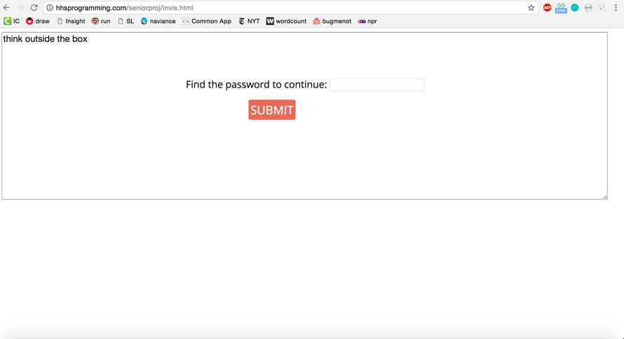In the invisible ink challenge, I created a webpage with a large box asking for a password. Inside the box, the text says, “think outside the box”.

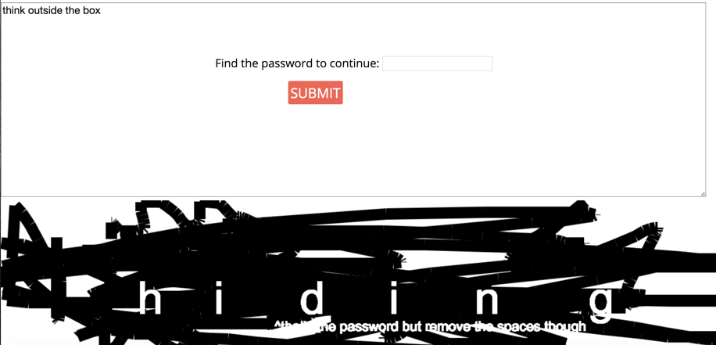The challenge is completed by moving the cursor outside of the box, where it turns into a brush. Clicking and dragging creates a black brush stroke, and brushing over the area outside the box reveals the passcode, “hiding”, which is written in white font, or “invisible ink”.

This challenge mainly serves to showcase something visually appealing that one can create with coding. After this challenge, I begin my presentation talking about hiding my freshman year.

1. View Source

In the view source challenge, the user is greeted with a blank webpage asking for a password with a hint, “You need to find the password in the source of this page! Right click (or control-click) and check out your browser options to see what's available”.

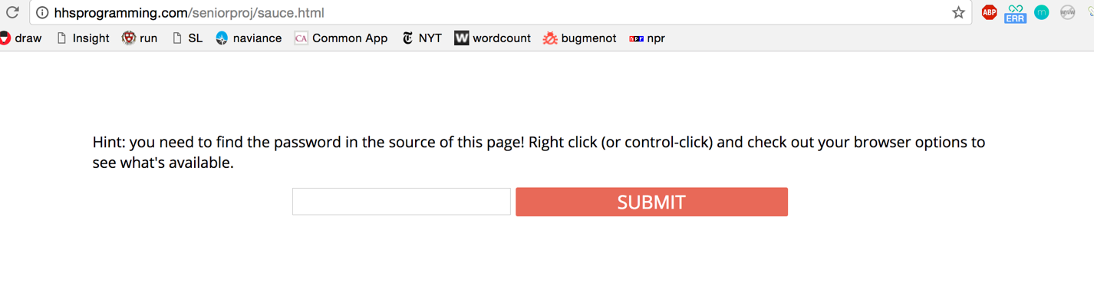

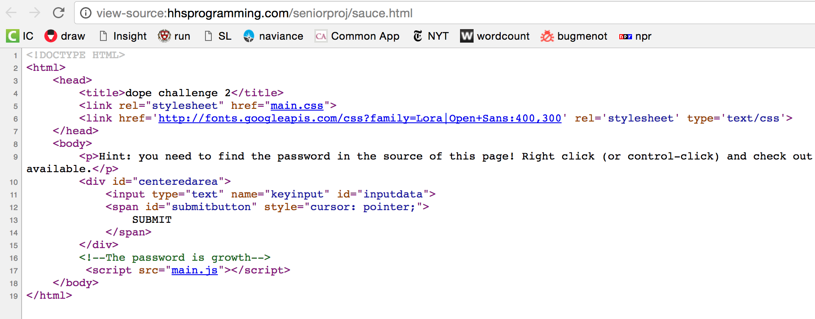 The challenge is completed by right clicking and viewing the source code of the page (the code that runs this part of the website) where the solution lies.

This challenge mainly serves to transition into a brief talk in which I explain that every website is actually just code, which the class had the opportunity to see in this case. The password is “growth”, so after this challenge I begin my discussion about growth.

1. Anagram

In the anagram challenge, a webpage allows the user to type something and then turns it into an anagram in a certain fashion. The goal of the challenge is to figure out how exactly the webpage manipulates the word that the user types, and use that knowledge to make the anagram into a certain jumble of letters.

The solution to the challenge is “FULF1LLMENT”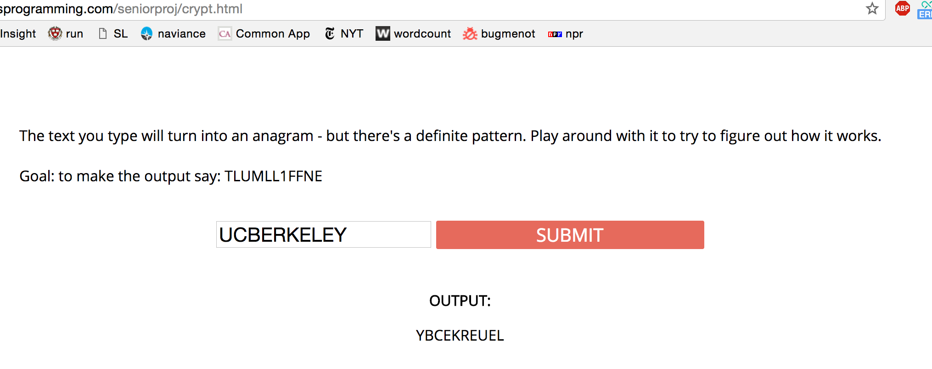, as it precedes the segment of my presentation on fulfillment.

1. The puzzle game

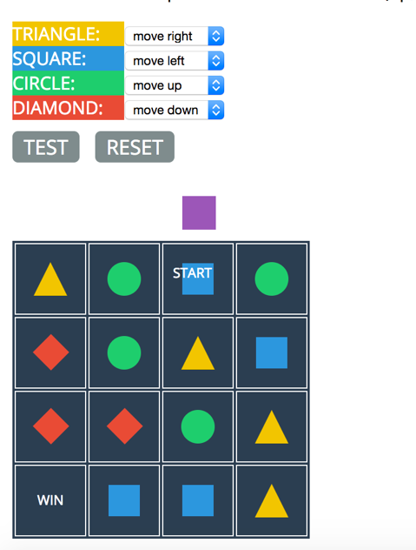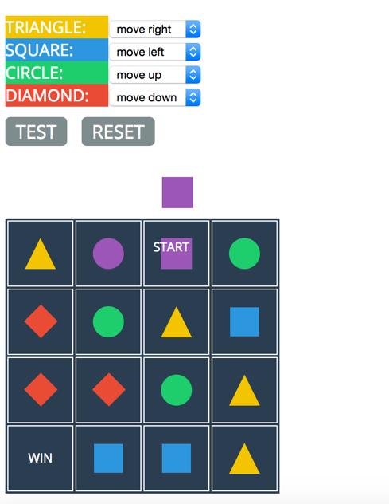I also coded a multi-level puzzle game, which, to stick with the Invisible Man references, we shall name the Invisible Game. I coordinated the concept of this game with Mr. Shelby and included it because I thought it would teach a certain aspect of coding to the class. I think that programming and computer science are about more ways of thought than they are about knowing the specifics of programming languages; similarly, this class is more about critical thinking and expressing ideas than it is about knowing literature terms. In this game, a grid is set up with shapes in each space.

The user must write rules for each shape. Once the user writes his rules and presses “test”, the starting shape turns purple. Then, whichever direction comes next also turns purple. This process continues until the purple hits a dead-end or reaches the “WIN”. The goal is to try to create a purple path to the “WIN” space. As shown in the right, the starting square is purple and the rule for squares is “move left”. The shape to the left of the square then also turns purple. The game becomes tricky with larger grids and the user has to think carefully to assign each shape to the correct direction.

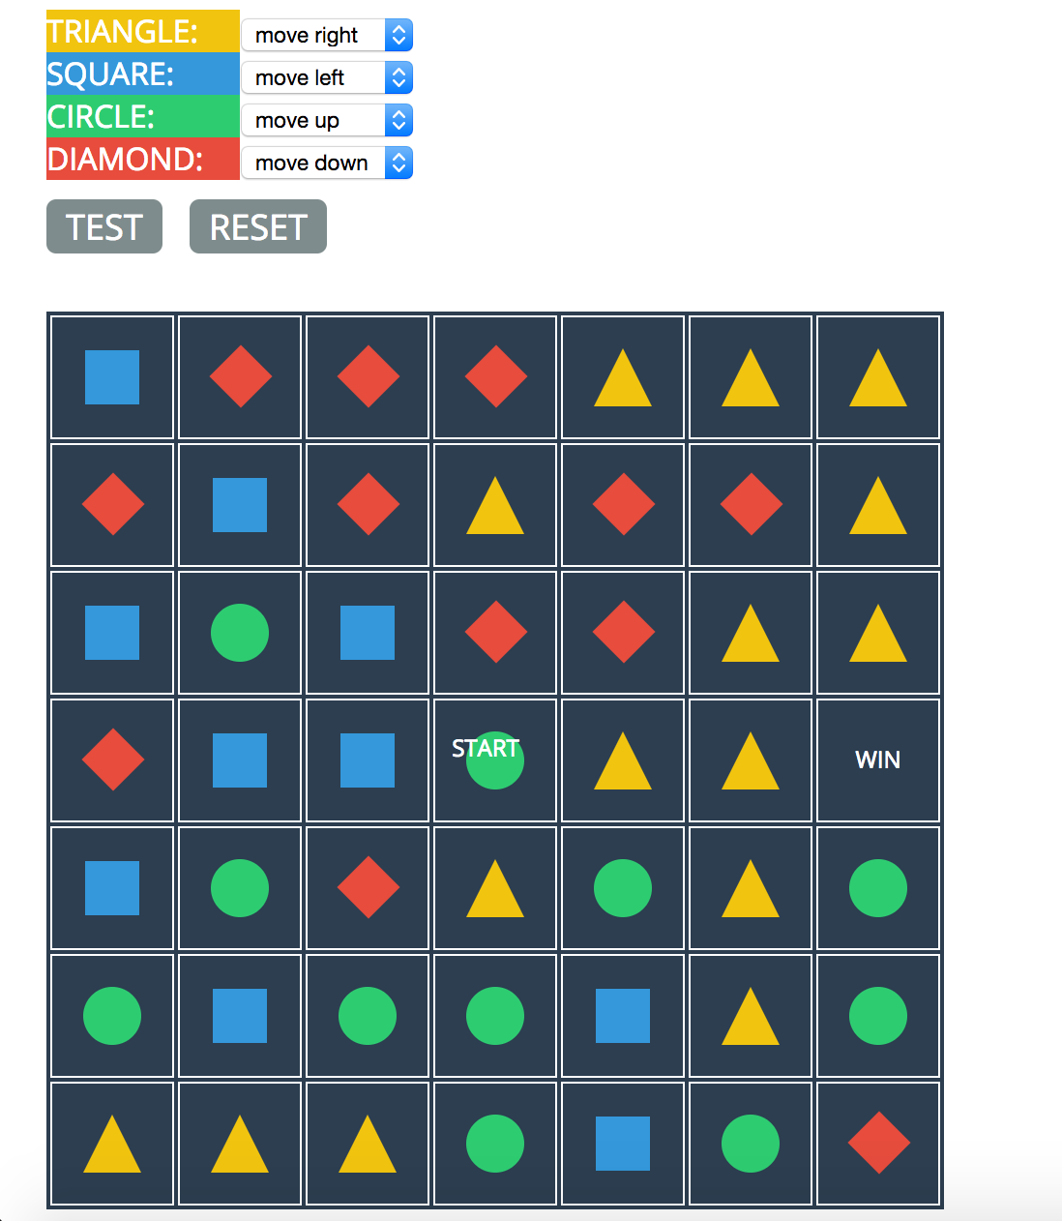

The game would be considered a puzzle game. In order to solve each level, the player has to think logically about each rule, imagining what will happen to the grid step-by-step before implementing a solution.

Writing rules in this game is similar to writing code in that menial labor is replaced with shorter, more complex guidelines that are only created once. The rules that the user assigns to each shape are like code; testing the rules is like running his code.